**Moderate to Severe Evaluation**

Sample_id :**XCKHHV(Cat)**

Link:<https://release.animalbiome.com/pet/assessment/report/summary/4a6f68ad-29fb-45ff-880a-c1519033ae91>

Cats and dogs:

Any two of the following:

(

High Red Flag Megamonas OR (failed)

High Red Flag Sutterella OR (failed)

High Red Flag Collinsella OR (failed)

Low Red Flag Bacteroides OR (failed)

Low Red Flag Blautia (**passed**)

);

OR

Cats:

11 or more yellow flags;(**Passed**)

OR 9 or more red flags;(failed)

High Red Megamonas,High red collinsella failed.

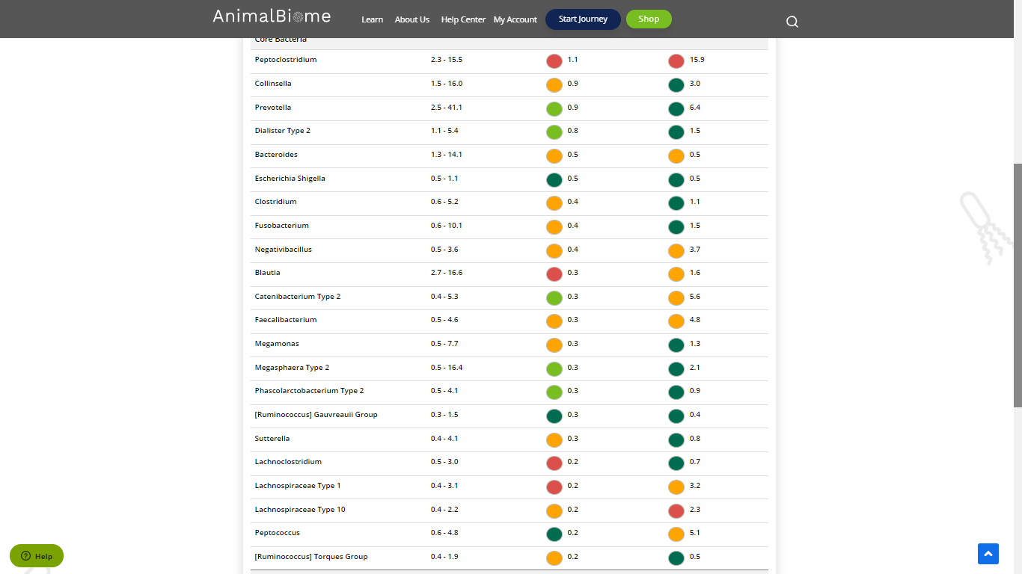

Low group evaluation:



low red blautia : passed.

Low red bacteroides : failed (1 condition satisfied ) in the primary group.

Total yellow flags : 11

Red flags : 6

The result : **False True False**

Moderate to severe results:Pass

Expected result : **Moderate to severe**

Achieved result : **passed.**

